StressAssess
www.stressassess.ca

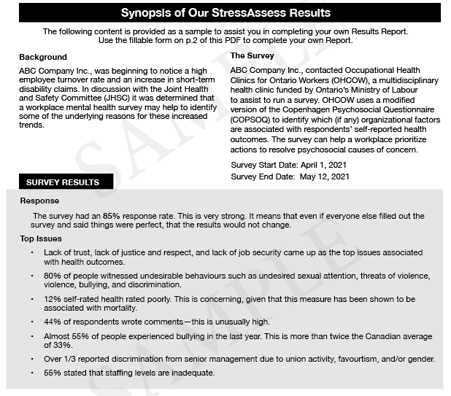

Use the form on the following pages to complete your
Survey Results Synopsis

Use your survey results to complete the following table:
Survey Results Synopsis

Background  Use this space to provide some background information about why you implemented a psychosocial survey in your workplace… | Survey Details  [Person/Committee Name] contacted Occupational Health Clinics for Ontario Workers (OHCOW), a multidisciplinary health clinic funded by Ontario’s Ministry of Labour to assist to run a survey. OHCOW uses an edited version of the Copenhagen Psychosocial Questionnaire (COPSOQ) to identify which (if any) organizational factors are associated with respondents’ self-reported health outcomes. The survey can help a workplace prioritize actions to resolve psychosocial causes of concern.  Survey Start Date:  Survey End Date:

SURVEY RESULTS
Response: Enter text here…

Use the Top Issues from your survey results to complete the following table:
TOP ISSUES
# | Issue(s)
1 | Enter text here…
2 | Enter text here…
3 | Enter text here…
4 | Enter text here…
To add more issues, tab down to add additional rows.

NEXT STEPS
# | Steps
1 | Enter text here…
2 | Enter text here…
3 | Enter text here…
To add more steps tab down to add additional rows.

Additional Notes:

