StressAssess
www.stressassess.ca
Results and Recommendations

Use this document to record the psychosocial factors that were identified in your survey results as areas needing improvement. Then document the solutions that are discussed and recommended by the survey committee. This will help to develop and organize your recommendations effectively. Use this completed document to table the concerns and recommendations to management – and begin the discussion for change.
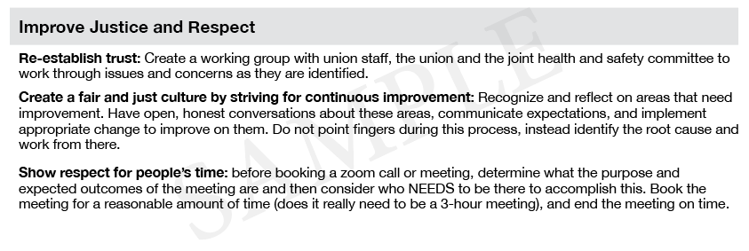
Use the Identified Concerns from your survey results to complete the following mini-table(s):

IDENTIFIED CONCERN
# | Recommendation

IDENTIFIED CONCERN
# | Recommendation

IDENTIFIED CONCERN
# | Recommendation

To continue building your Results and Recommendations,
copy/paste additional IDENTIFIED CONCERN mini-tables here.

Additional Notes:

