StressAssess
www.stressassess.ca
Recommendation Work Plan and Tracking Tool
The following table is provided as a sample to assist you in preparing your recommendations for presentation.
If you are in a large organization, with several different departments consider completing this tool with each department.

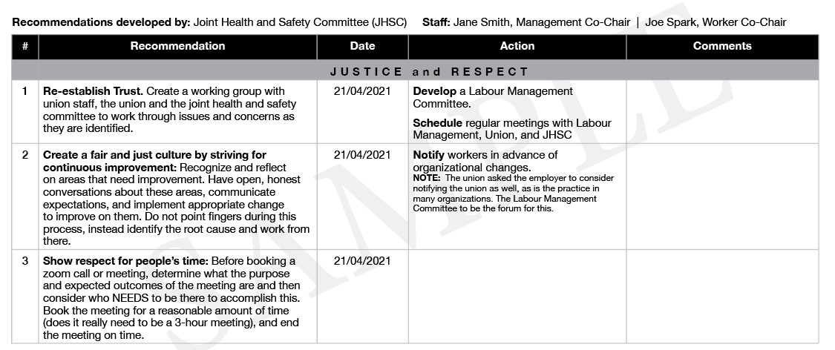

Recommendation Work Plan and Tracking Tool
Developed by: | Staff:

Use the Identified Concerns from your survey results to complete the following mini-table(s):
IDENTIFIED CONCERN
# | Recommendation | Date | Action | Comments

IDENTIFIED CONCERN
# | Recommendation | Date | Action | Comments

IDENTIFIED CONCERN
# | Recommendation | Date | Action | Comments

IDENTIFIED CONCERN
# | Recommendation | Date | Action | Comments

To continue building your Recommendations Work Plan and Tracking Tool,
copy/paste additional IDENTIFIED CONCERN mini-tables here.

